**FPT ACADEMY INTERNATIONAL**



## FPT – APTECH COMPUTER EDUCATION

CHRISTONE STORE

|  |  |  |  |
| --- | --- | --- | --- |
| **Center Name** | | FPT – Aptech – HCM2  Address: 590 Cach Mang Thang Tam, District 3, Ho Chi Minh City | |
| **Instructor** |  | Ms. Le Mong Thuy |  |
| **Class** |  | T1.2007.E1 |  |
| **Group** |  | 5 |  |
| **Group members** | | **Name** | **Student ID** |
|  |  | Liêu Quỳnh Như | Student1269829 |
|  |  | Nguyễn Hữu Phú | Student1270643 |
|  |  | Nguyễn Huy Thuộc | Student1271267 |
|  |  | Huỳnh Minh Trí | Student1119861 |
| **Duration** | Start date | 19th September 2020 |  |
| End date | 19th October 2020 |  |

**This is to certify that**

**Mr / Ms.:**

Liêu Quỳnh Như

Nguyễn Hữu Phú

Nguyễn Huy Thuộc

Huỳnh Minh Trí

**has successfully designed & developed**

eProject: Crystal store website

**Submitted by:**

Liêu Quỳnh Như

**Date of issue:**

**Authorized Signature:**

# 

# ACKNOWLEGMENT

On behalf of all the members of group 5, I would like to thank you all for the hard works, supports to make this eProject complete successfully. Especially, Ms. Le Mong Thuy, our teacher, she helped us a lot from the day that we started to study at FPT Aptech. With this eProject, she has guided us with her enthusiasm and rigorous, because of her guiding, we would be able to finish this project. Besides, I want to thank all the team member of group 5, each of the team member has been working continuously in 4 weeks in order to complete this project. The last but not least, we would like to say thank you to our family for always supporting us, creating the best conditions for us to focus on the project, and putting faith in the dreams we pursue.

# SYNOSIS

We need to create a website that meet all the requirement of our customer, Crystal Store. Crystal Store is a crystal selling website that not only provide a crystal quartz but also jewelry and decorate homes. They have a big collection about all gemstone. The main purpose of this website is to reach to the customer, who have interest in crystal and looking for a place that they can research with their passion. Come to Crystal Store, customer can learn about gemstones and other specialties

# PROBLEM DEFINITION

# Today, people are drawn to crystals for a number of reasons, including primarily that they are very beautiful objects and their different shapes, sizes and colours have proved fascinating and mysterious as well.  They can be found in various forms of beautiful jewellery, or on their own in rough uncut specimens that are sometimes used as ornaments to decorate homes.

# Crystals are used to enhance the body's own healing abilities, reduce stress and improve the quality of your life. They hold a massive amount of energy and those who work with them believe that they have their own individual energy field or personality.

# Holding crystals or placing them on your body is thought to promote physical, emotional and spiritual healing. Crystals supposedly do this by positively interacting with your body's energy field, or chakra. While some crystals are said to alleviate stress, others purportedly improve concentration or creativity

# CUSTOMER'S REQUIREMENTS SPECIFICATIONS (CRS)

### Business/Project Objective:

Crystal Store is a crystal store that not only provide a crystal quartz but also jewelry and f decorate homes. They have a big collection about all gemstone. The main purpose of this website is to reach to the customer, who have interest in crystal and looking for a place that they can research with their passion. Come to Crystal Store, customer can learn about gemstones and other specialties

We are supposed to create a website for them with the below mentioned requirement specifications.

The website is to be developed for the Windows Platform using HTML5, JavaScript, Bootstrap, jQuery and Geolocation. The site should work well in all leading browsers including Chrome, IE, Firefox etc.

**Input to the system:**

* + - * Searching products based on Crystal Type, Name of product.
      * Purchase, order products on website.
      * Register members on website.

**Output from the system:**

* The Home Page should be created making use of Sections with a suitable logo, the header section can be added which will show images of various products.
* The site must contain the links to navigate through any category for the information.
* The site should display a menu which will contain the options for brief introduction about the various products available, location of the shop and any other information if required.
* The information should be categorized according to the various crystals like if a User wants to see only “Diamond/Amber/Amethyst etc” products then he/she can click on a Link/button/menu etc and can see only that crystal products.
* When a user selects any particular crystal, a list of all the products for that crystal will be displayed
* A brief summary of features of the product should be displayed on the Web Page along with the picture but detailed Features should be stored in Individual Word documents which can be downloaded or viewed by the User who wishes to see the same.
* The user should also be able to compare the various products
* There should be a “Contact Us” page which will have the Address of the Company which should be displayed using GeoLocation API (eg. GoogleMaps) and the email address which when clicked will invoke the local mail client from where they can send an email.

### Hardware/ Software Requirements:

* **For developer**

**Hardware**

* A minimum computer system that will help you access all the tools in the courses is a Pentium 166 or better
* 64 Megabytes of RAM or better

**Software**

* Notepad/HTML editor
* Dreamweaver
* IE 5.0/ Netscape 6.0
* Visual Code
* **For web users**

**Hardware**

* A minimum computer system that will help you access all the tools in the courses is a Pentium 166 or better
* 64 Megabytes of RAM or better

**Software**

* Notepad/HTML editor
* Dreamweaver
* IE 5.0/ Netscape 6.0
* Visual Code

# SCOPE OF THE WORK (IN BRIEF)

After a long and detailed discussion, our group has decided to create a website contain the following webpages:

1. ***Homepage*** : Display information about newest-selling products, an introduction about Crystal Store.
2. ***About Us***: Display the information of the company, clients’ review and about us.
3. ***Product*** : Display all available collection based on category ( crystal type, function, color, category…..)
4. ***Contact***: Display the address of the company, allow customers to request any information they want to Crystal Strore .
5. ***Download Document*** : download the detail for each product : price , quality ….. in word file
6. ***Cart***: review orders and proceed to check out page.
7. ***Check out***: Display total bill and confirm order.
8. ***New Arrival :*** *Display incoming new product*
9. ***Special Offers :*** *Display product in the special discount / event*

# Architecture and design of the system

Webpage request



Requested Page

**RENDERING**

**ENGINE**

**CSS CODE**

**HTML CODE**

**WEB SERVER**

**WEB BROWSER**

**CLIENT**

**SERVER**

# Diagram of the website

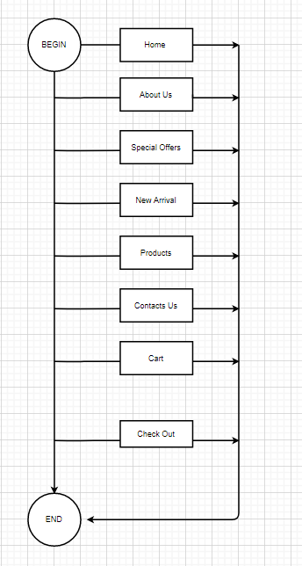



# TASK SHEET REVIEW 1

|  |  |  |  |  |  |  |  |
| --- | --- | --- | --- | --- | --- | --- | --- |
| **Project Ref. No.:**  **eP/Advertisement Portal Management**  **System/01** | | **Project Title:** | **Activity Plan Prepared By:** | **Date of Preparation of Activity Plan:** | | | |
| **Sr.**  **No.** | **Task** | **Actual**  **Start Date** | **Actual Days** | **Team**  **Mate Names** | **Status** |
| 1 | Problem Statement | Crystal Store | Như | 19-Sep-20 | 1 | Như | Completed |
| 2 | Analysis of Crystal Store requirements about the website | 19-Sep-20 | 1 | Như | Completed |
| 3 | The scope of the work (in brief) | 19-Sep-20 | 1 | Phú | Completed |
| 4 | Architecture and design of the system | 19-Sep-20 | 1 | Thuộc | Completed |
| 5 | Diagram of the website | 19-Sep-20 | 1 | Trí | Completed |
| 6 | Task Sheet | 19-Sep-20 | 1 | Như | Completed |

|  |  |
| --- | --- |
| **Date:** | |
| Signature of Instructor:  **Ms. Le Mong Thuy** | Signature of Team Leader:    **Liêu Quỳnh Như** |

# SITE MAP

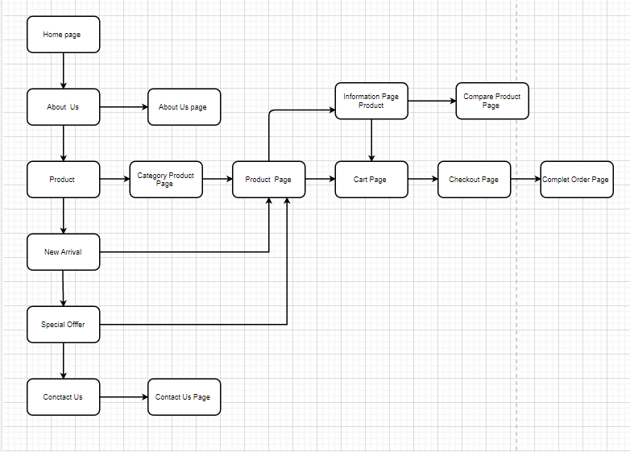

# MOCK OF THE WEBSITE

1. **Homepage**

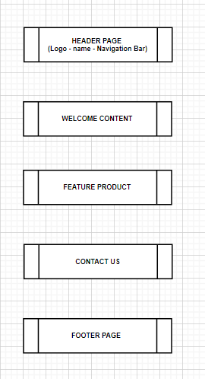

1. **About Us**

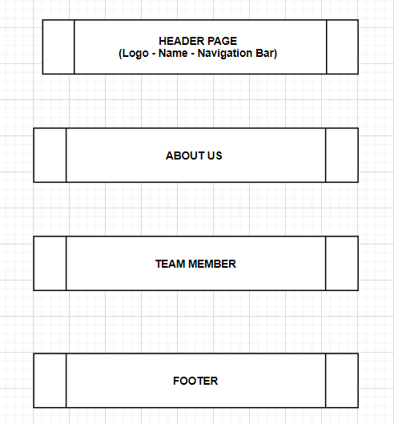

1. **All Product Category**

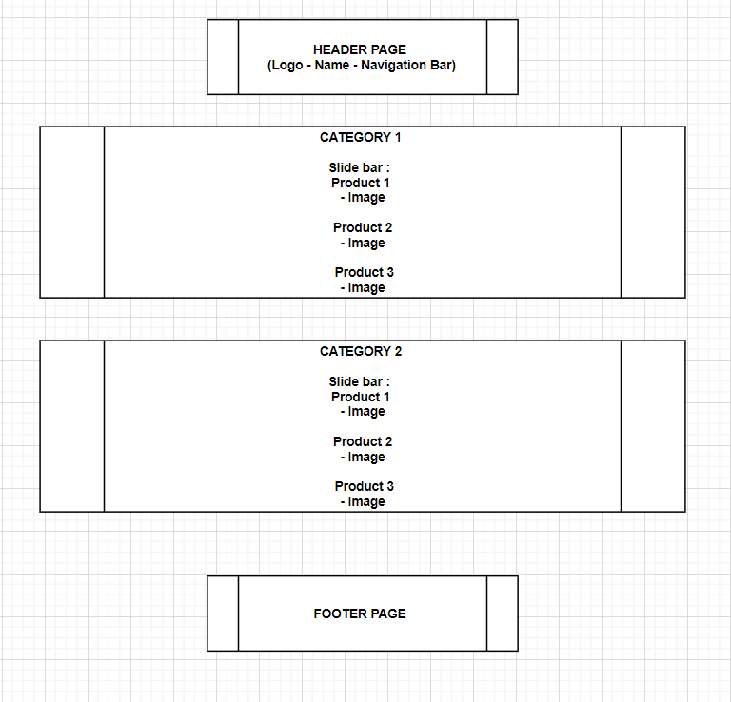

1. **Product category**

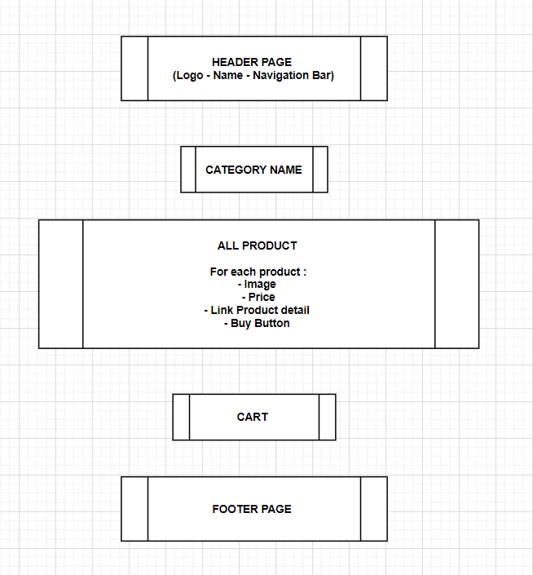

1. **Product detail**

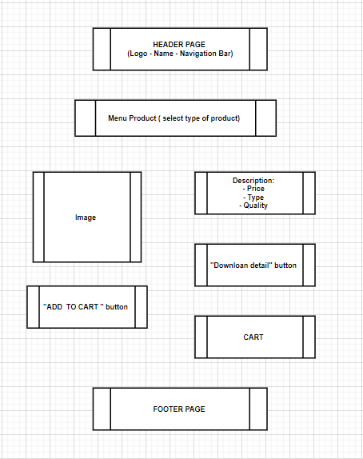

1. **Download Product**

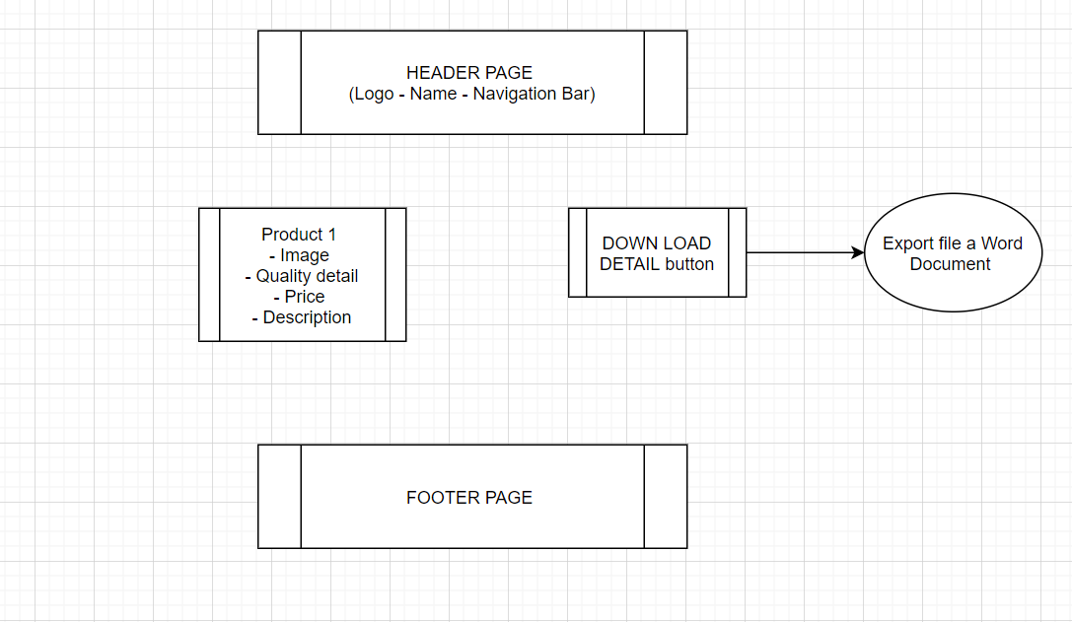

1. **Cart**

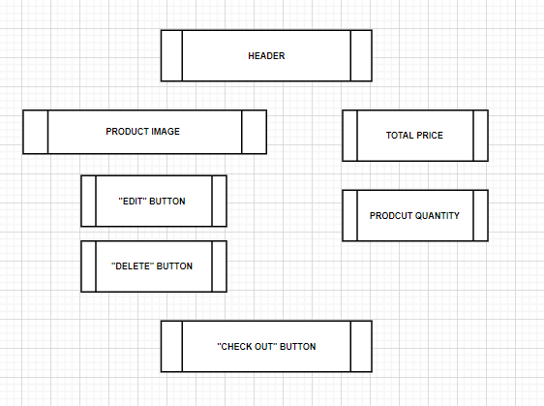

1. **Check out**

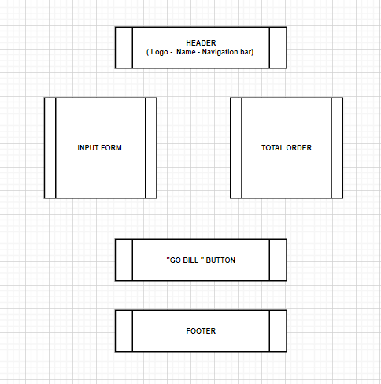

1. **Bill Page**

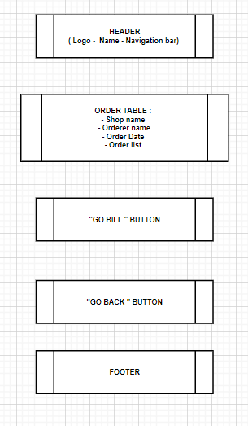

# TASK SHEET REVIEW 2

|  |  |  |  |  |  |  |  |  |  |
| --- | --- | --- | --- | --- | --- | --- | --- | --- | --- |
| **Project Ref. No.:**  **eP/Advertisement**  **Portal Management System/01** | | **Project Title:** | **Activity Plan Prepared By:** | | **Date of Preparation of Activity Plan:** | | | | |
| **Sr.**  **No.** | **Task** | **Actual Start Date** | **Actual Days** | **Team Mate Names** | **Status** | |
| 1 | Site map | Crystal Store | Như | | 26-Sep-20 | 1 | Nhu | Completed | |
| 2 | Mock of the website | 26-Sep-20 | 2 | Thuoc, Tri, Phu | Completed | |
| 3 | Task sheet | 26-Sep-20 | 2 | Nhu | Completed | |
|  |  |  |  | |  |  |  |  | |
| **Date: 26/09/2020** | | | | | | | | |
| Signature of Instructor:  **Ms. Le Mong Thuy** | | | | Signature of Team Leader:    **Liêu Quỳnh Như** | | | | |

# 

# WEBSITE DESCRIPTION

1. **Home Page**
2. Description

Home page displays following information:

* Menu bar
* Welcome content
* Feature Product / New Arrival
* Contact us
* Cart

1. Screen shot

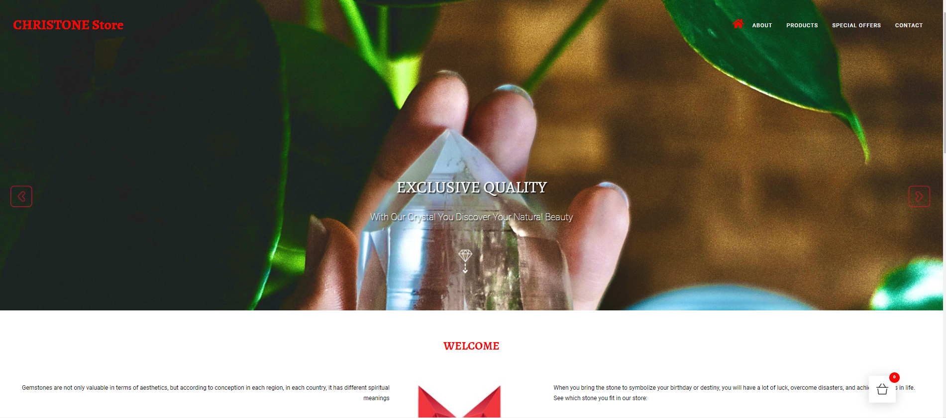

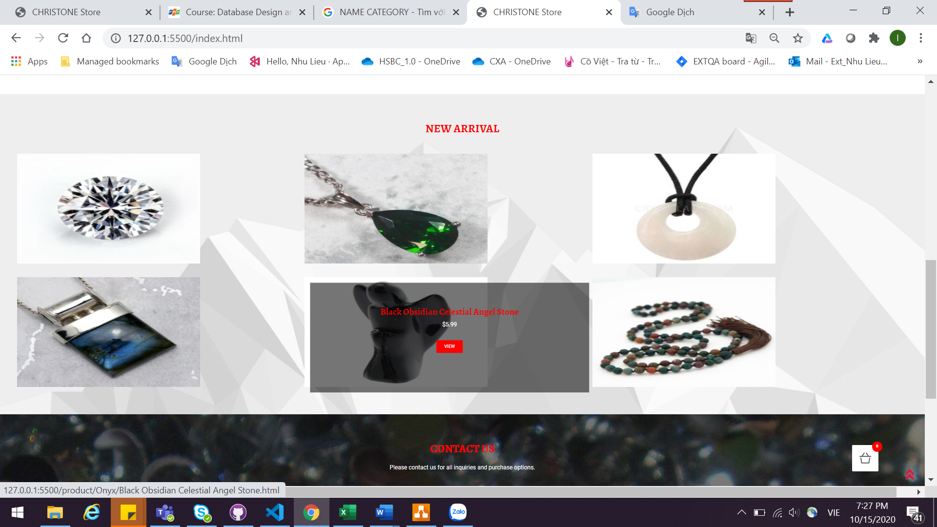

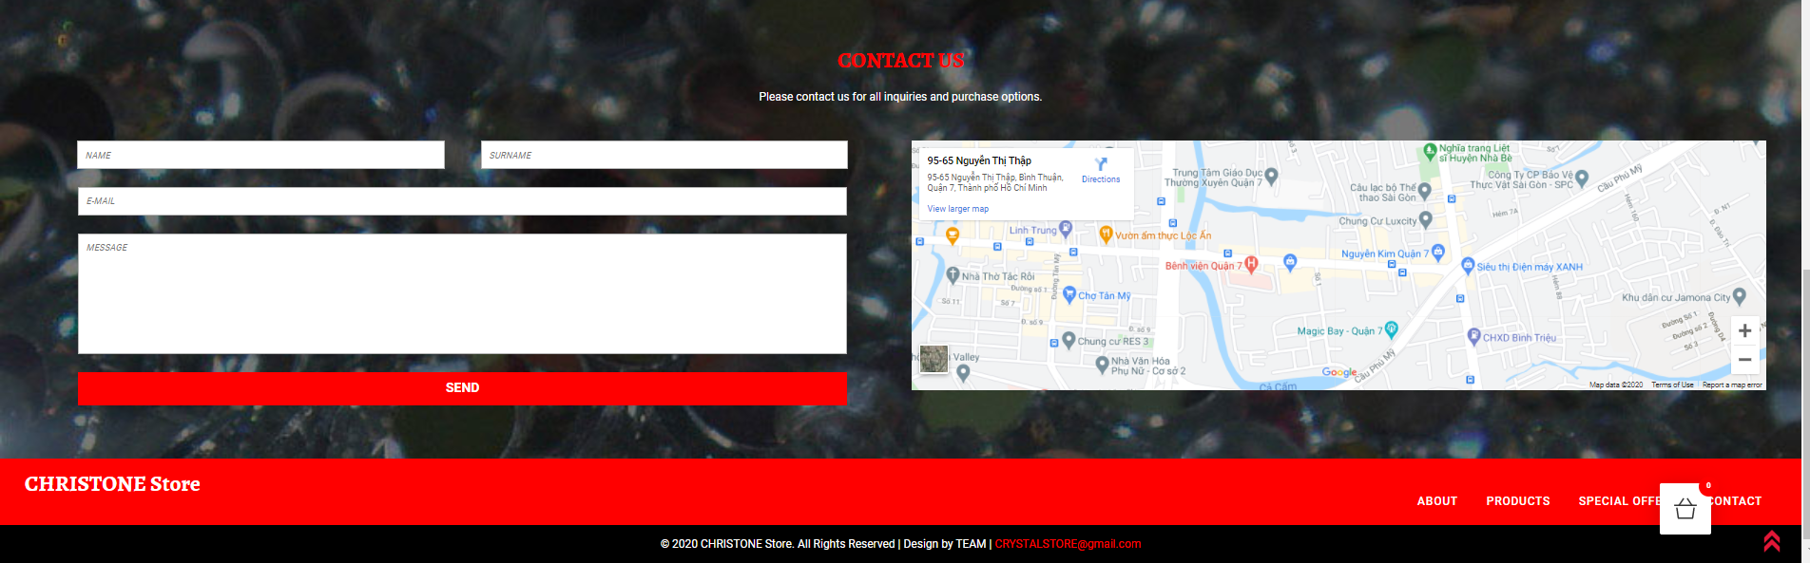

1. **About Us**
2. Description

* Menu bar
* This page displays information about the history of Christone, our service that we provide and our team member.
* Contact Us : can send the email directly at mail box in wed page or via orther browser

1. Screen shot

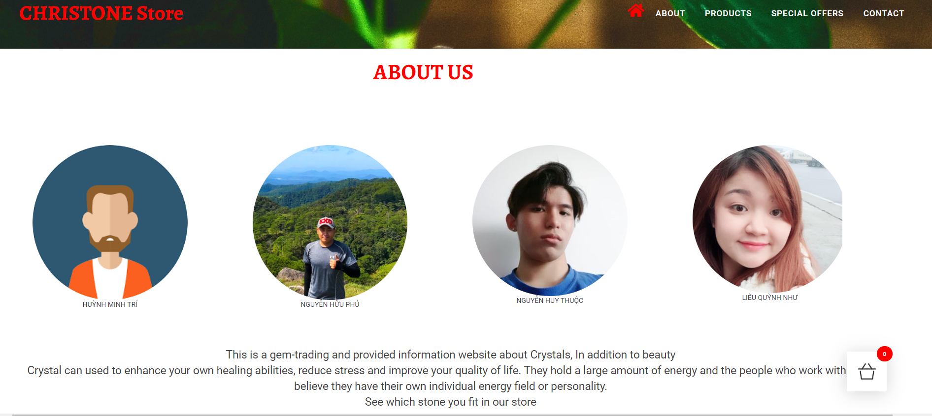

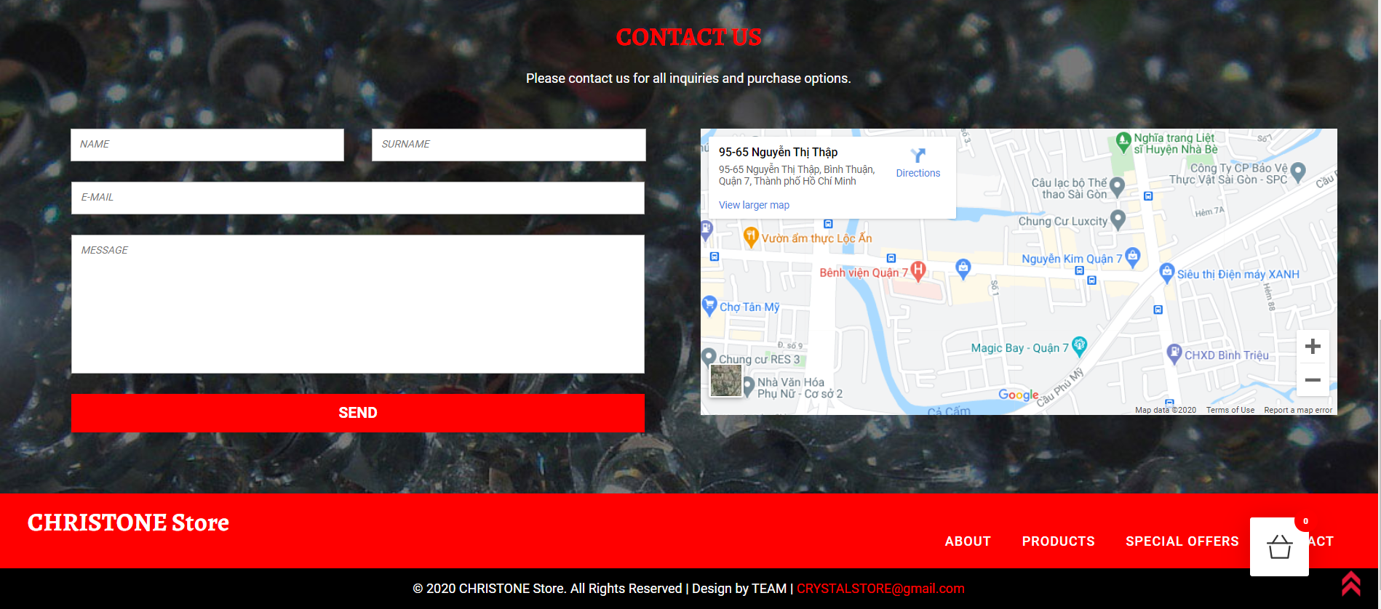

1. **Special offer**
2. Description

* This page display product in the special discount / event
* The price for each price
* Link go to product detail when click on View button
* Product display: Can add to Cart and go to Check Out

1. Screen Shot

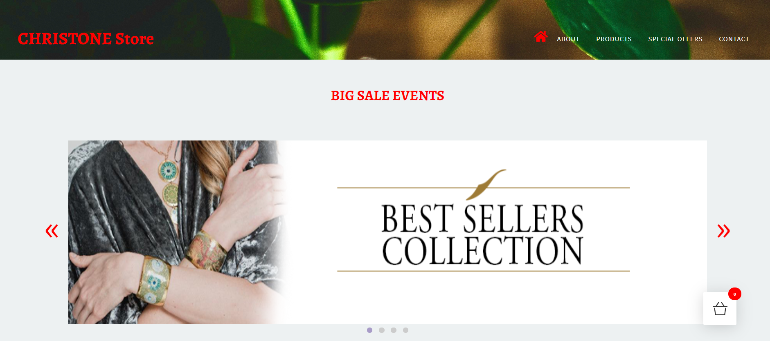

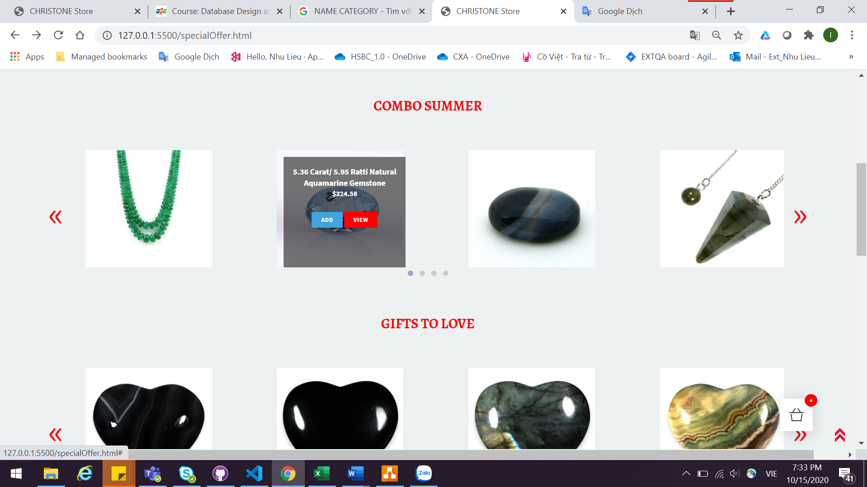

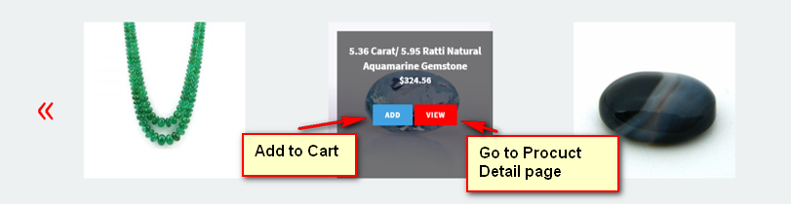

1. **New Arrival**
2. Description

* Display incoming new product
* The price for each price
* Link go to product detail when click on View button

1. Screen Shot

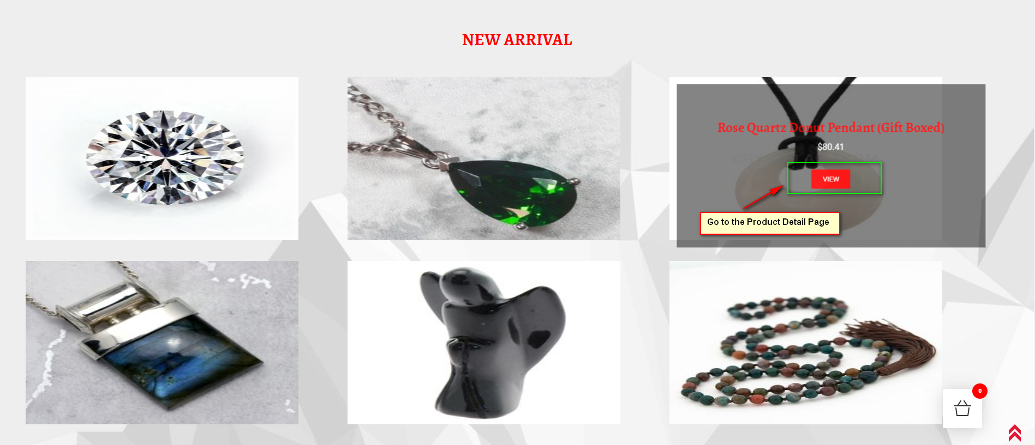

1. **All Product Category**
2. Description

* This page display all available collection based on category ( crystal type, function, color, category…..) in slide Bar
* Link go to product Category when click on Image

1. Screen Shot

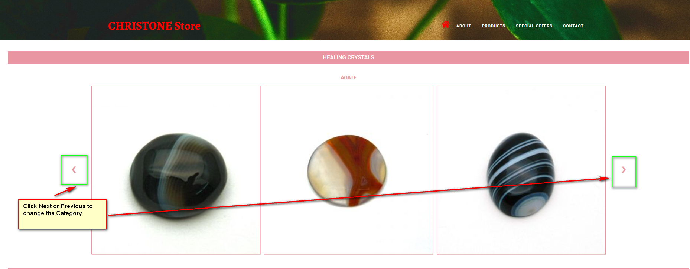

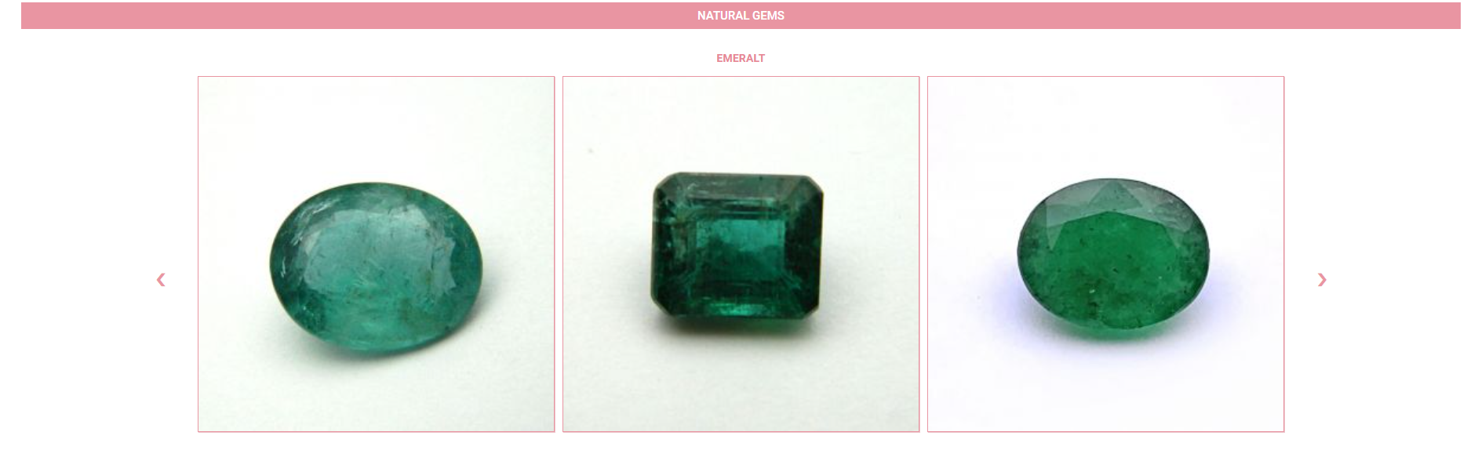

1. **Product Category**
2. Description

* View all product of category selected
* Add to Cart directly via “Buy Now” button
* Contact Us

1. Screen shot

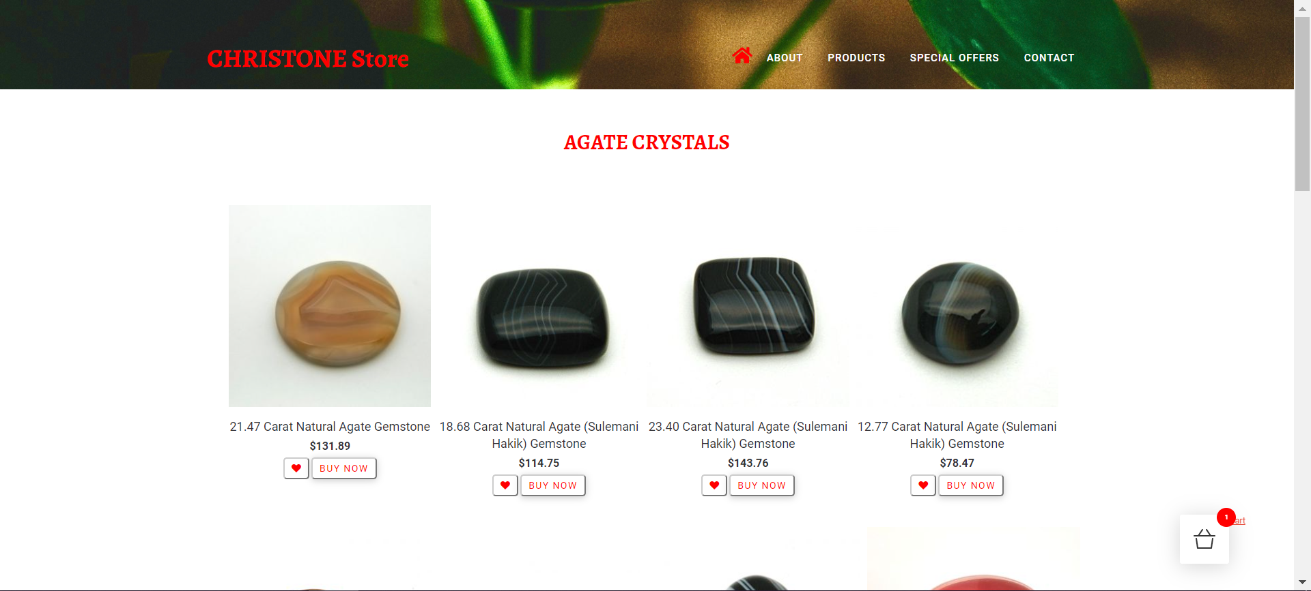

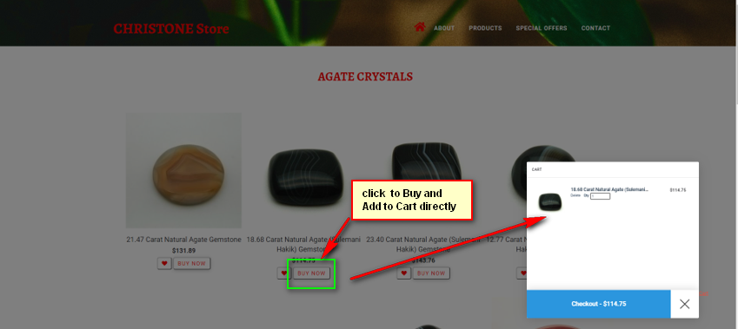

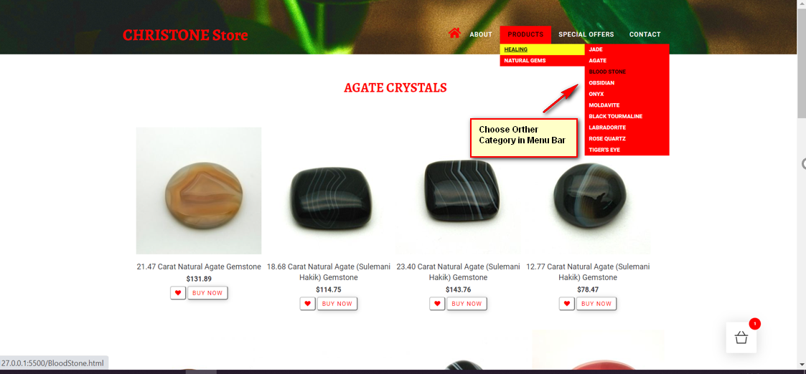

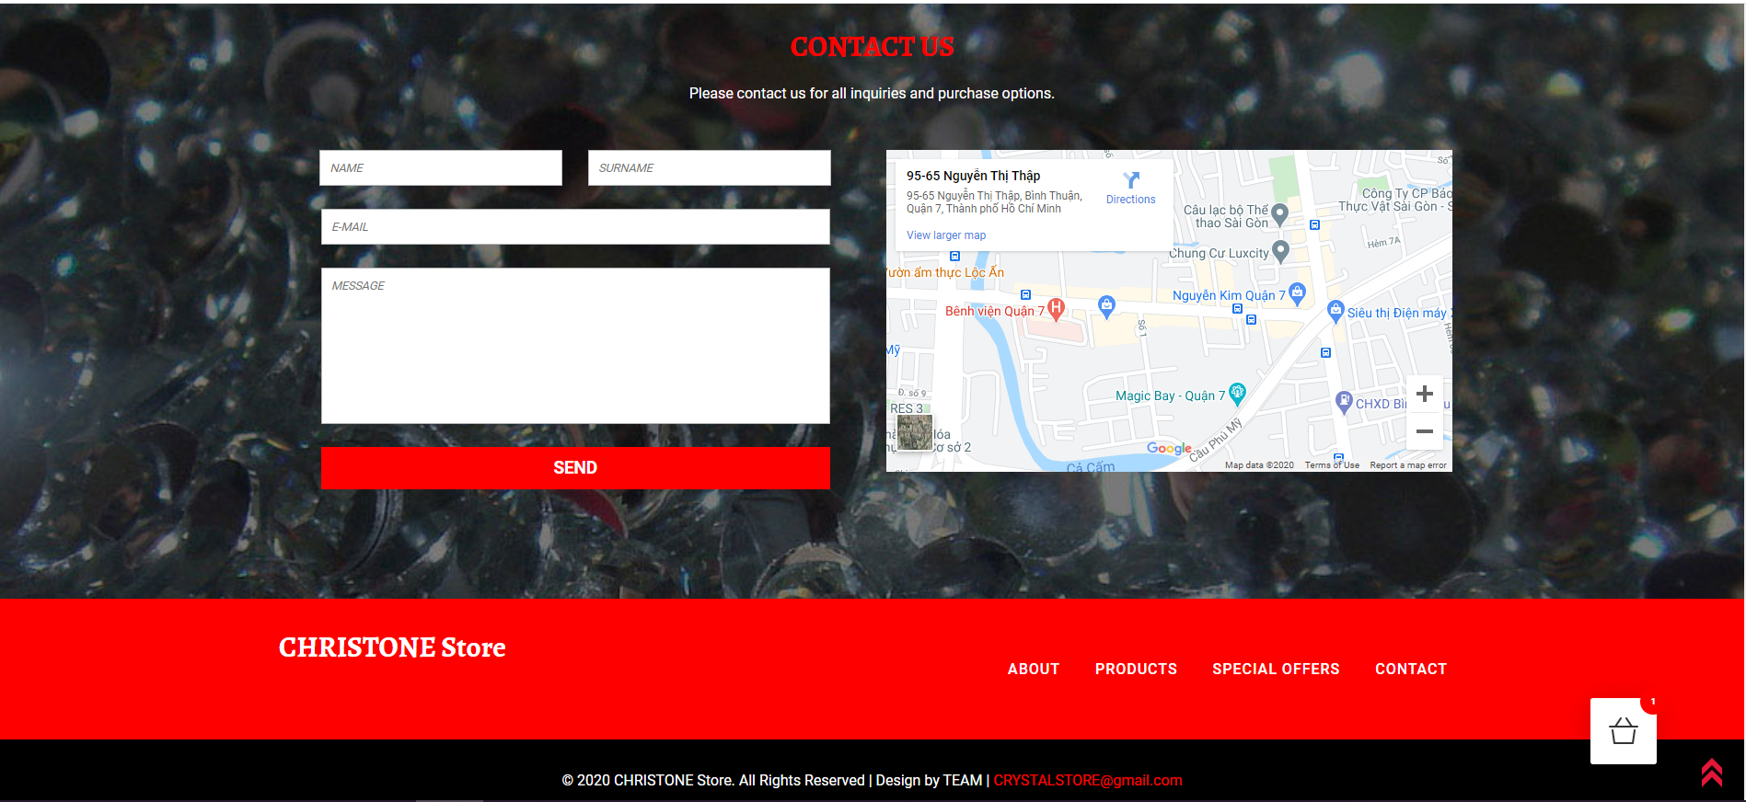

1. **Product description:**
2. Description:

* View Description detail of product selected
* Download detail of product
* “Add to cart” button to buy
* Contact Us

1. Screen Shot :

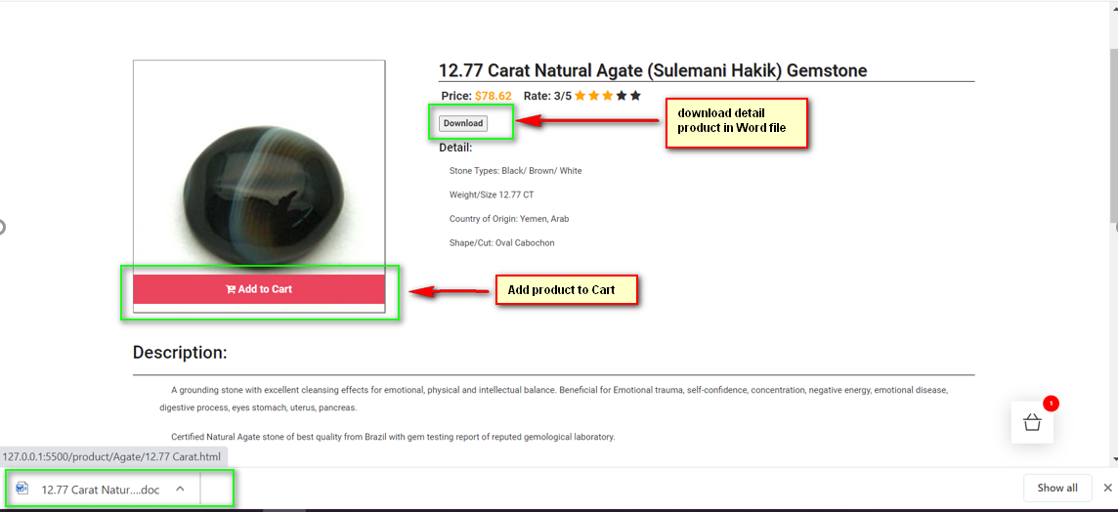

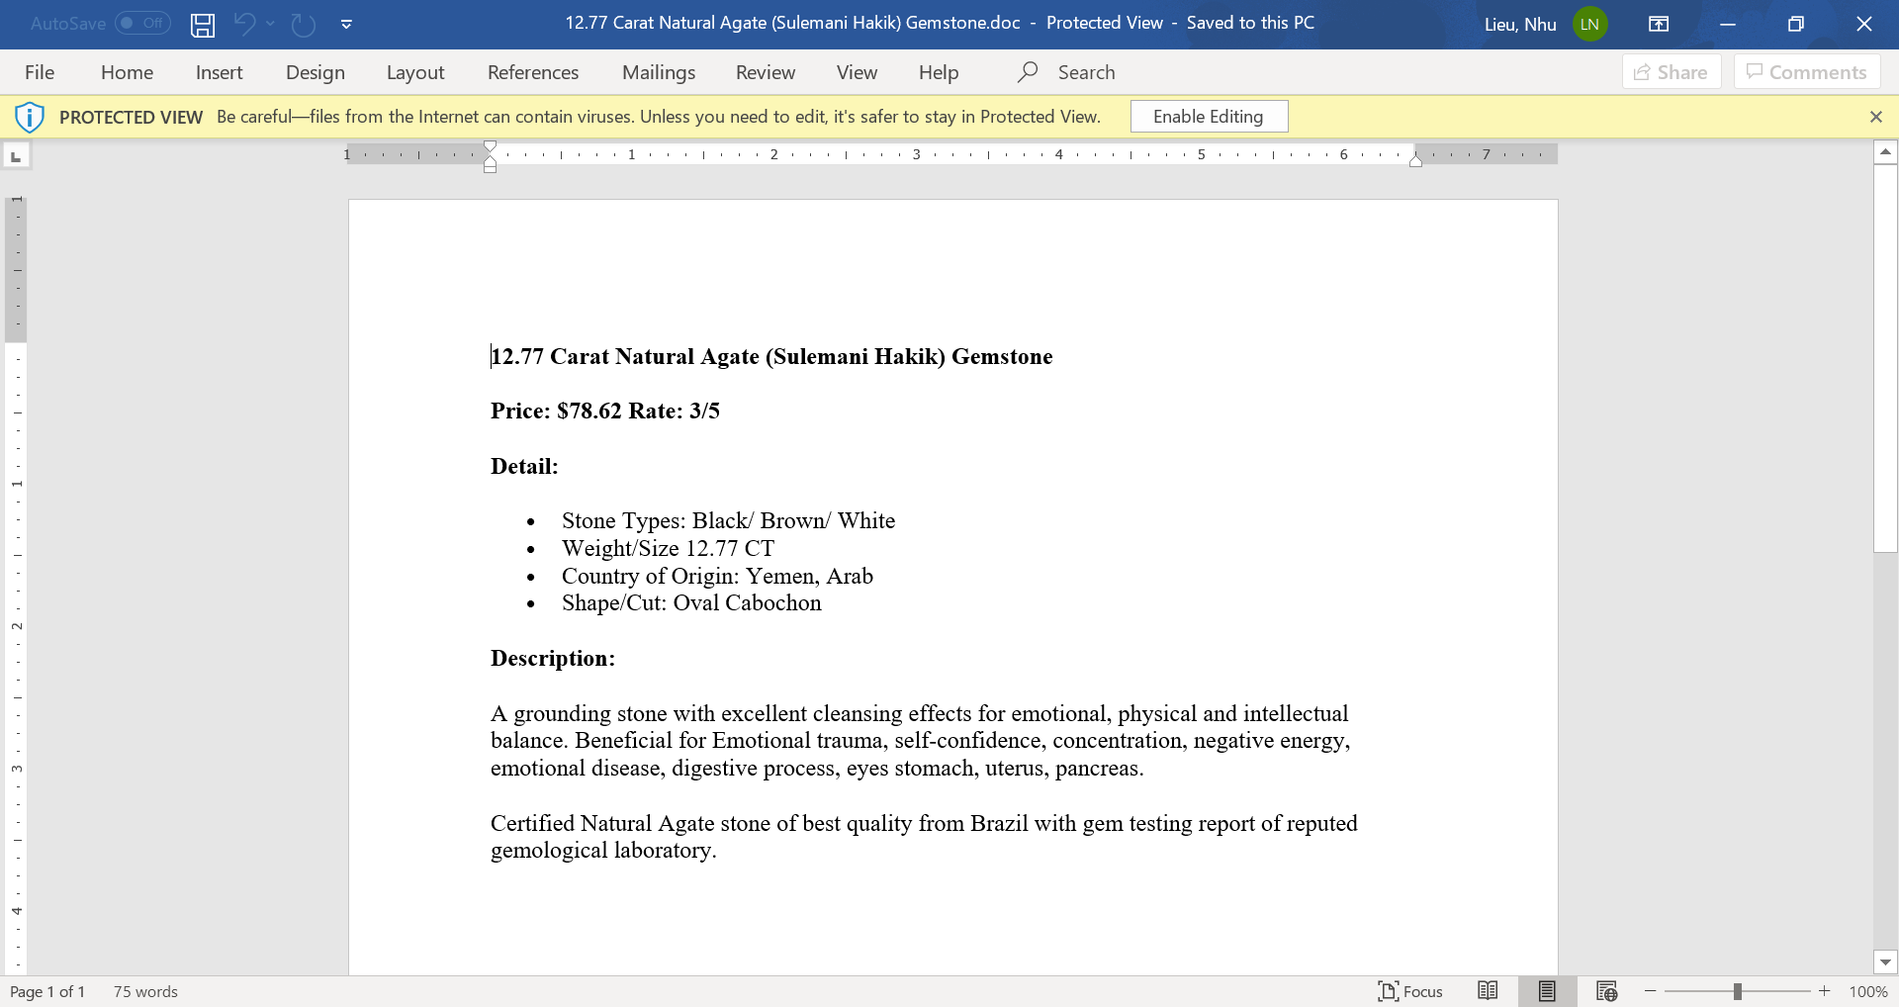

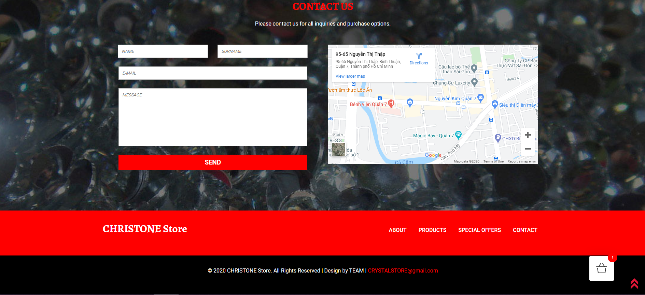

1. **Cart**
2. Description

This page display information:

* Review, delete orders
* Quantity product
* Total amount
* Check Out button

1. Screen shot

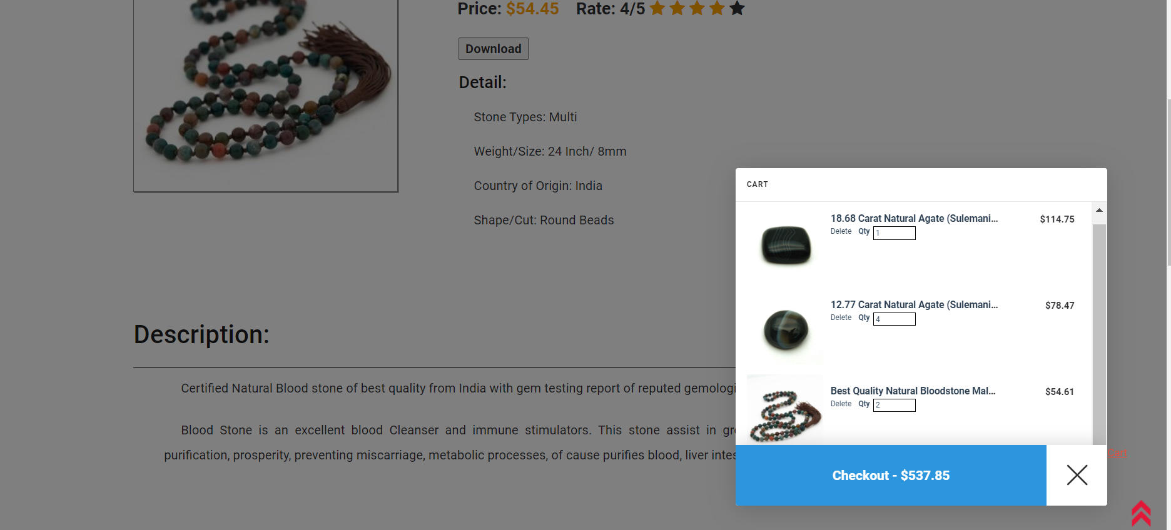

1. **Check out**
2. Description

This page display information:

* Total bill
* Confirm order.
* Input information form
* Go Bill button
* Contact Us

1. Screen shot :

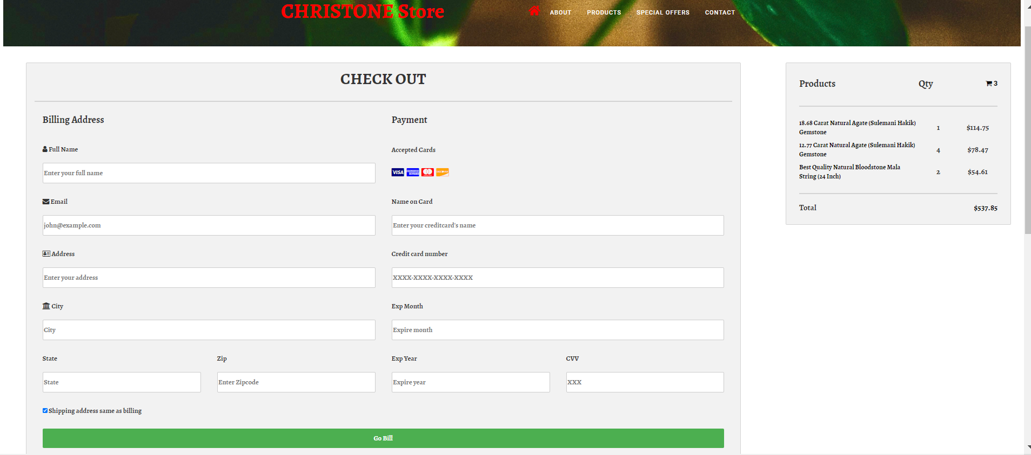

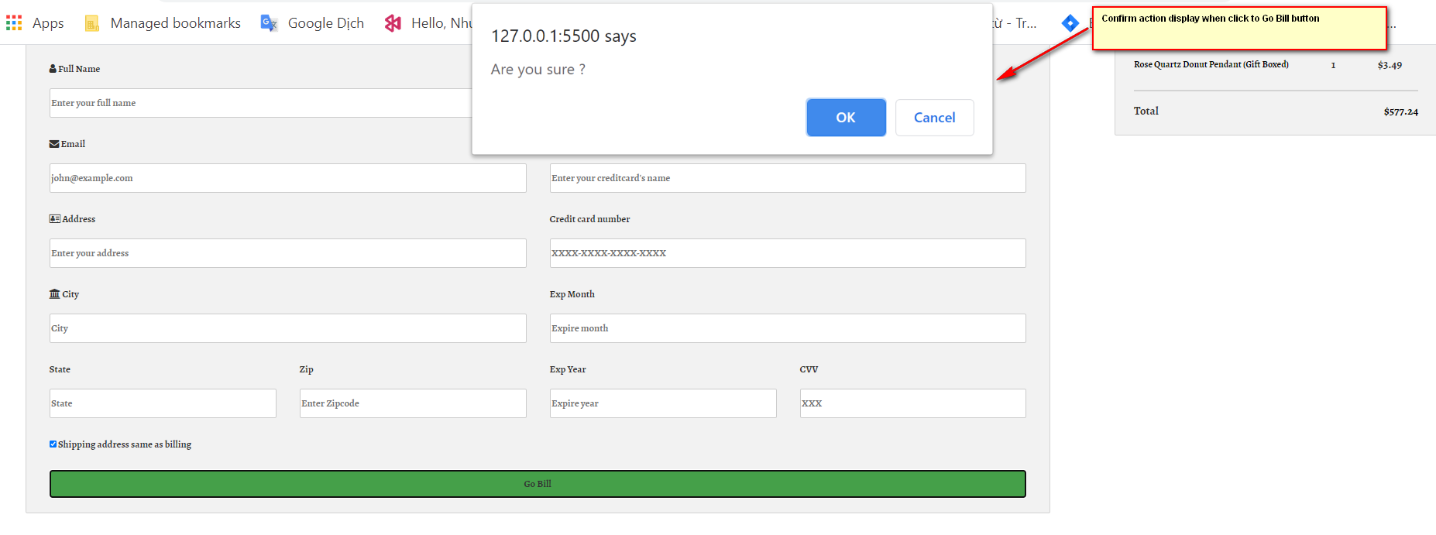



1. **Bill page:**
2. Description :

This page display information:

* Inform Bill after payment
* Contact

1. Screen shot :

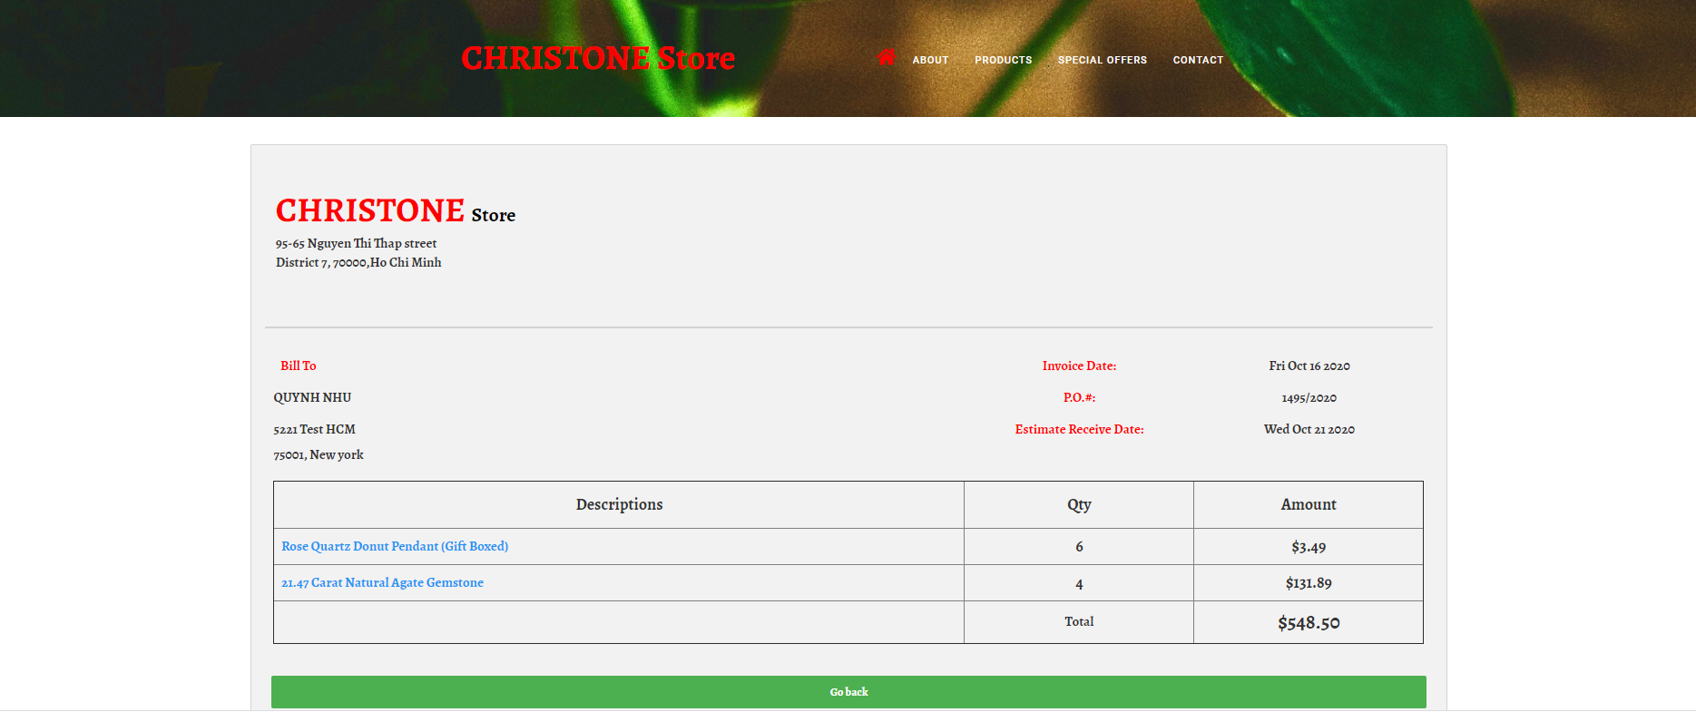

1. **Contact Us**
2. Description

* This page displays contact information: location, telephone number, email and a quick contact form for customer.
* Contact Us : can send the feed back directly at mail box in wed page or via orther browser to mail store

1. Screen shot

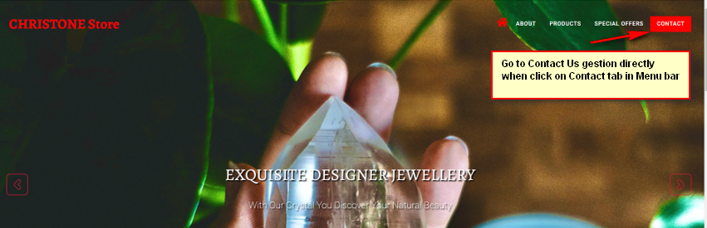

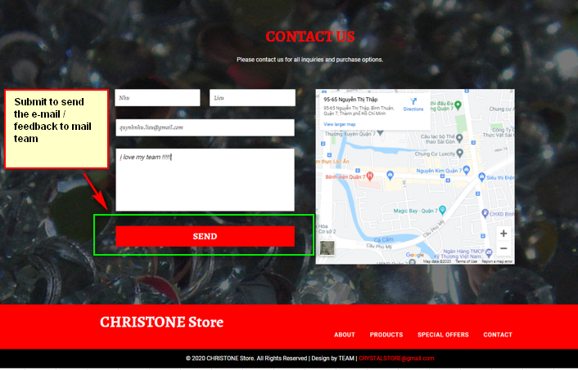

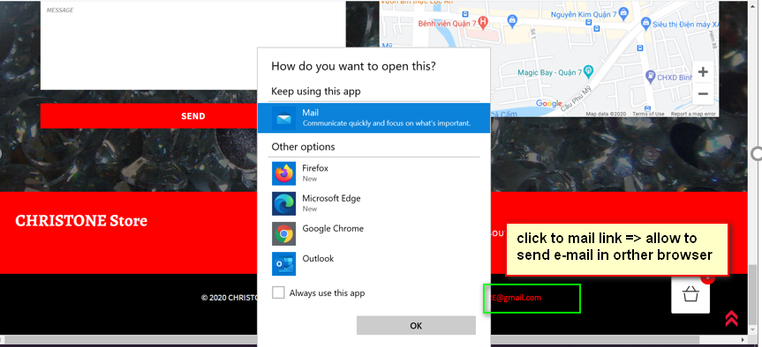

# WEBSITE DESCRIPTION

1. **Slider javascript**
2. Decription

This script used slick package (carousel) to display the products on the website.

1. Screen shot

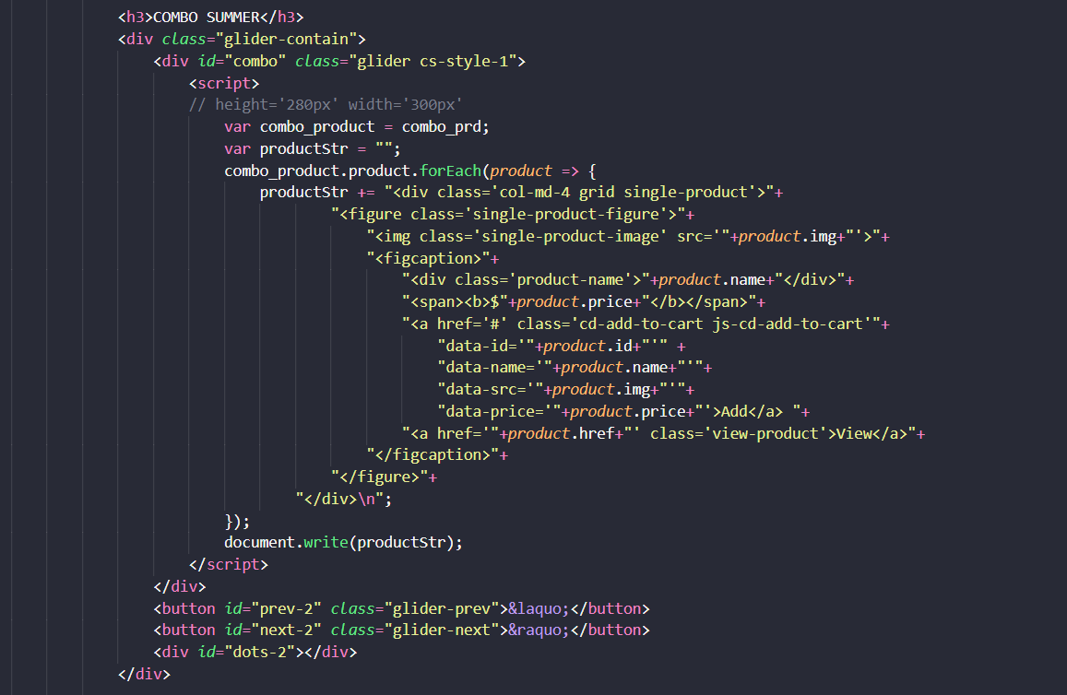

* The product data in special offer page is loaded from the json file

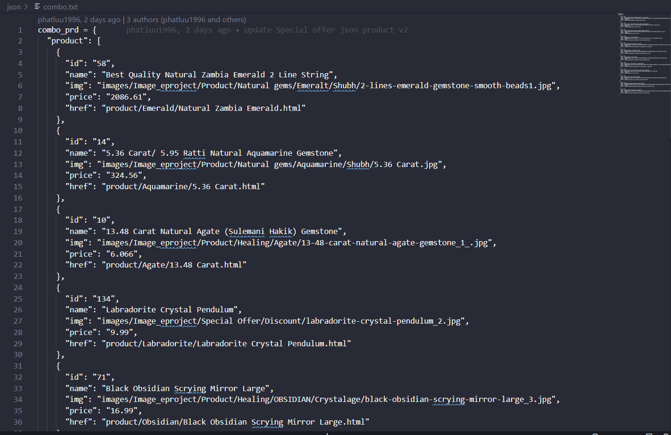

1. **Add product to cart javascript**
2. Description

This script used for adding product in cart page.

1. Screen shot

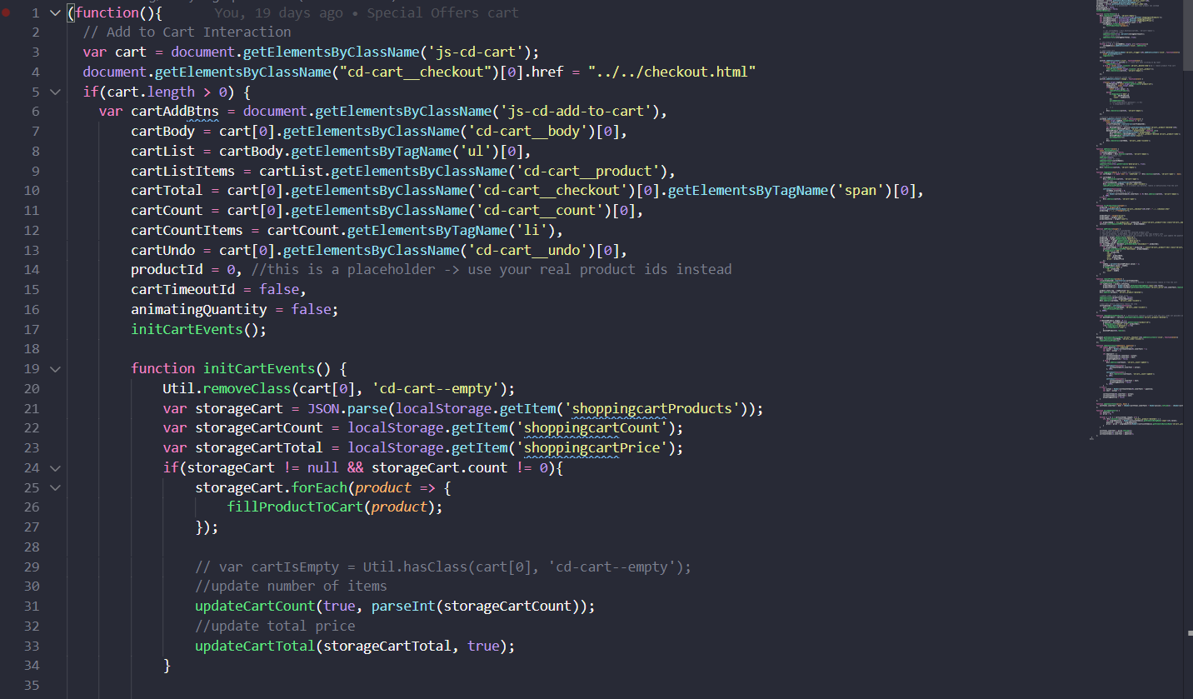

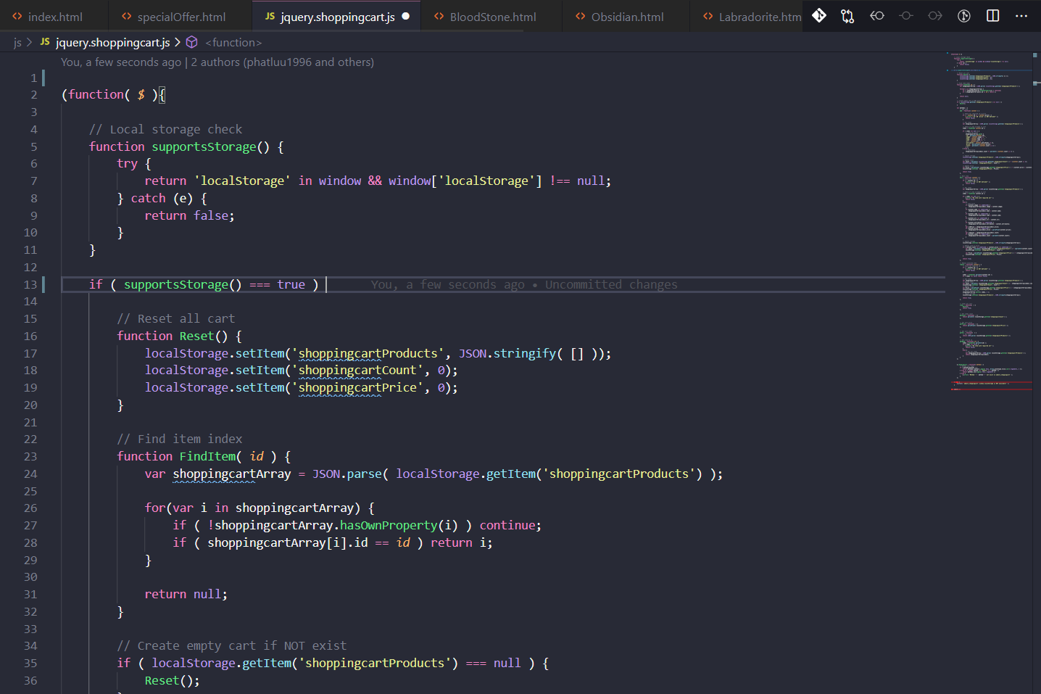

1. **Download detail javascript**
2. Description

This script used for download detail of each product as Word

1. Screen shot

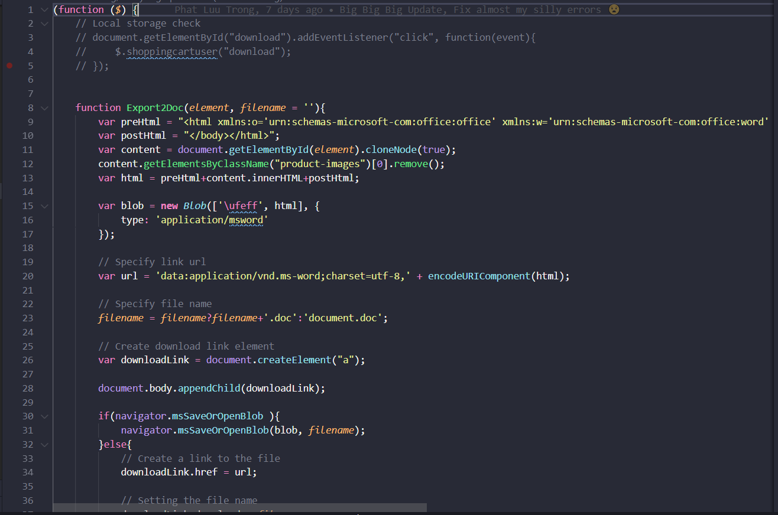

1. **Cart javascript**
2. Description

This script used for display all the items that being purchased.

1. Screen shot

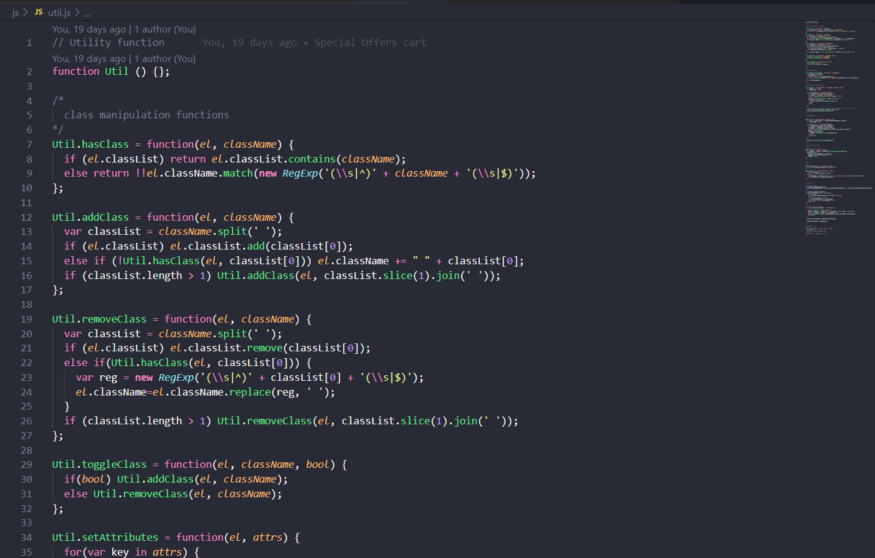

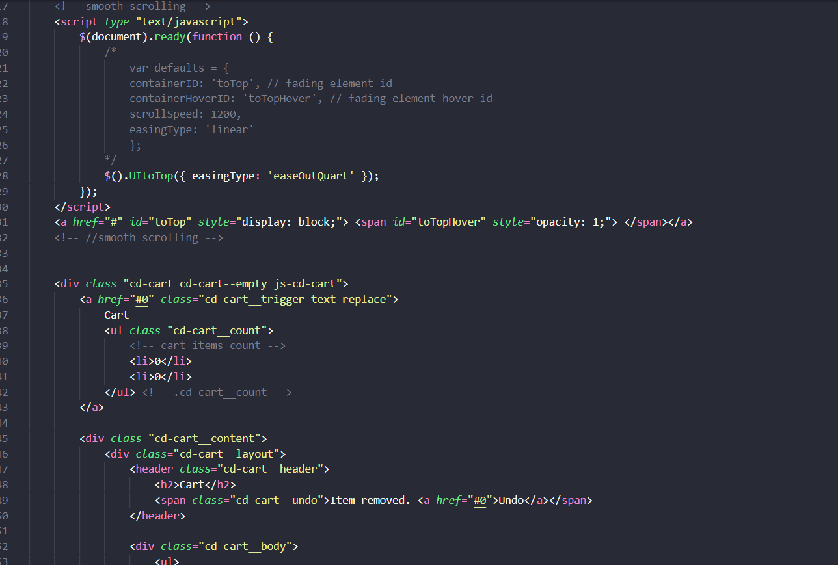

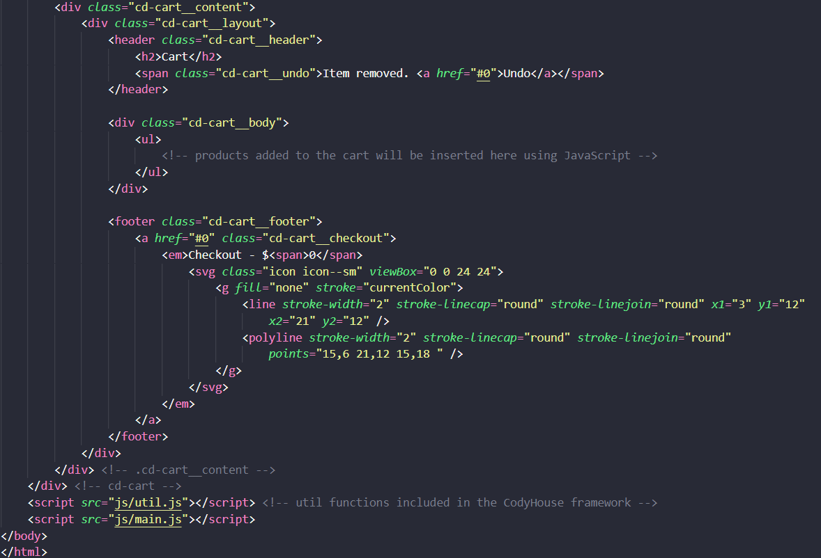

1. **Check out javascript**
2. Description

This script used for display the total items and price in check out page.

1. Screen shot

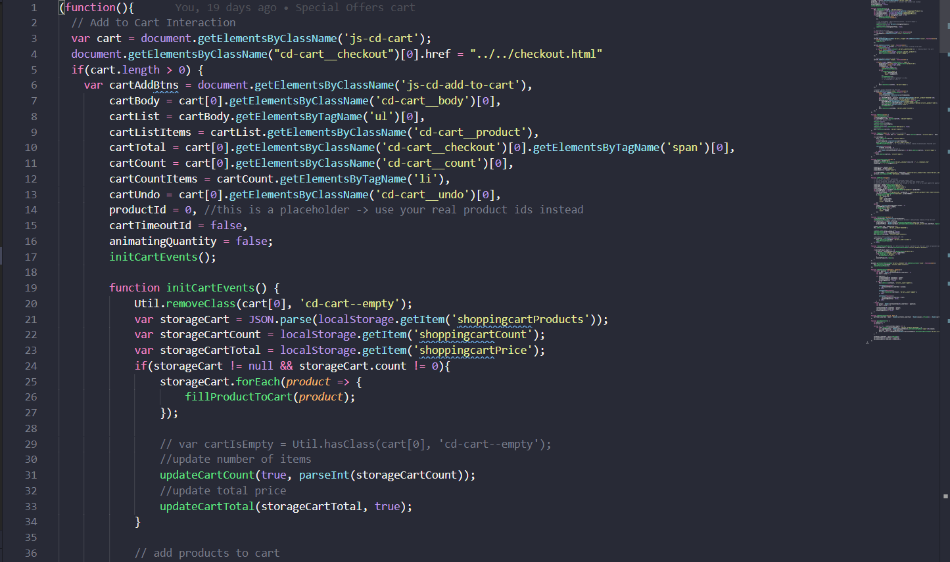

1. **Create Bill javascript**
2. Description

This script used for save and display information that client to input in Check Out page

1. Screen shot

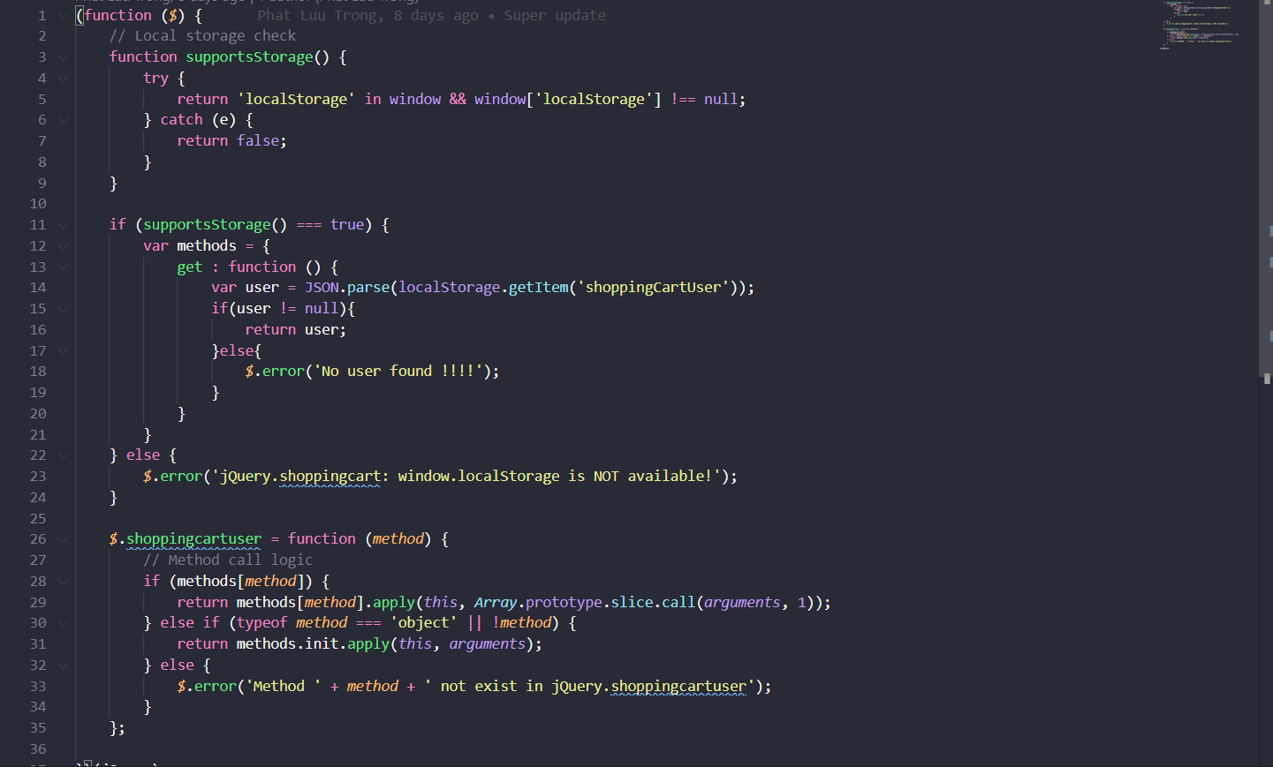

# 

# TASK SHEET REVIEW 3

|  |  |  |  |  |  |  |  |
| --- | --- | --- | --- | --- | --- | --- | --- |
| ***Project Ref. No.:***  ***eP/Advertisement Portal Management System/01*** | | ***Project Title:*** | ***Activity Plan Prepared By:*** | ***Date of Preparation of Activity Plan:*** | | | |
| ***Sr.***  ***No.*** | ***Task*** | ***Actual Start***  ***Date*** | ***Actual Days*** | ***Team Mate***  ***Names*** | ***Status*** |
| *1* | *Home page* | *Christone Store* | *Như* | 26-Sep-20 | *1* | *Thuộc* | *Completed* |
| *2* | *About US* | 26-Sep-20 | *2* | *Thuộc* | *Completed* |
| *3* | *New Arrival* | 26-Sep-20 | *1* | *Trí* | *Completed* |
| *4* | *Product* | 26-Sep-20 | *1* | *Phú, Trí* | *Completed* |
| *5* | *Product detail* | 27-Sep-20 | *2* | *Phú* | *Completed* |
| *6* | *Special Offer* | 26-Sep-20 | *1* | *Như* | *Completed* |
| *7* | *Contact us* | 26-Sep-20 | *1* | *Thuộc* | *Completed* |
| *8* | *Cart* |  |  | 30-Sep-20 | *1* | *Như* | *Completed* |
| *9* | *Download Detail* |  |  | 30-Sep-20 | *1* | *Như* | *Completed* |
| *10* | *Check out* |  |  | 01-Oct-20 | *1* | *Như* | *Completed* |
| *11* | *Bill* |  |  | 01-Oct-20 | *1* | *Như* | *Completed* |
| *12* | *Javascript* |  |  | 29-Sep-20 | *1* | *Như, Phú* | *Completed* |
| *13* | *User Guide* |  |  | 26-Sep-20 | *1* | *Như* | *Completed* |

|  |  |
| --- | --- |
| **Date: 15/10/2020** | |
| Signature of Instructor:  **Ms. Le Mong Thuy** | Signature of Team Leader:    **Liêu Quỳnh Như** |